1st: Heat Map: All of Europe, click on the countries to show the specific number of immigration (SVG tooltip).

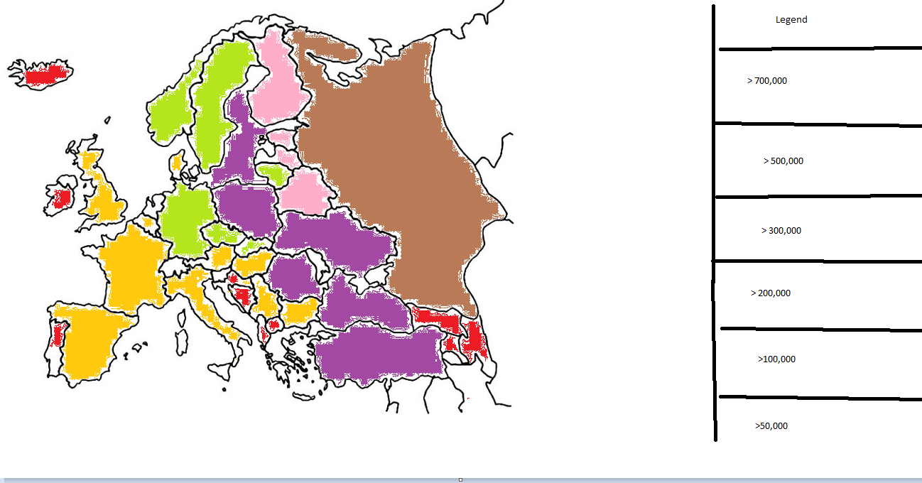

2nd: Stacked bar chart (woman vs Men immigration) able to change the data by year  
x-axis = different countries, y-axis = 50,000 ticks



<https://eige.europa.eu/gender-statistics/dgs/indicator/ta_demigr_migr_imm__migr_imm1ctz/bar/year:2020/geo:BE,BG,CZ,DK,DE,EE,IE,EL,ES,FR,HR,IT,CY,LV,LT,LU,HU,MT,NL,AT,PL,PT,RO,SI,SK,FI,SE,IS,LI,NO,CH,UK,ME,MK,TR,BA,AM,AZ,BY,MD,RU/citizen:TOTAL/agedef:REACH/age:Y10-14/unit:NR/sex:M,W>

3rd: Line Graph, immigration over time for european countries, able to change different countries using (<https://d3-graph-gallery.com/graph/line_select.html>)

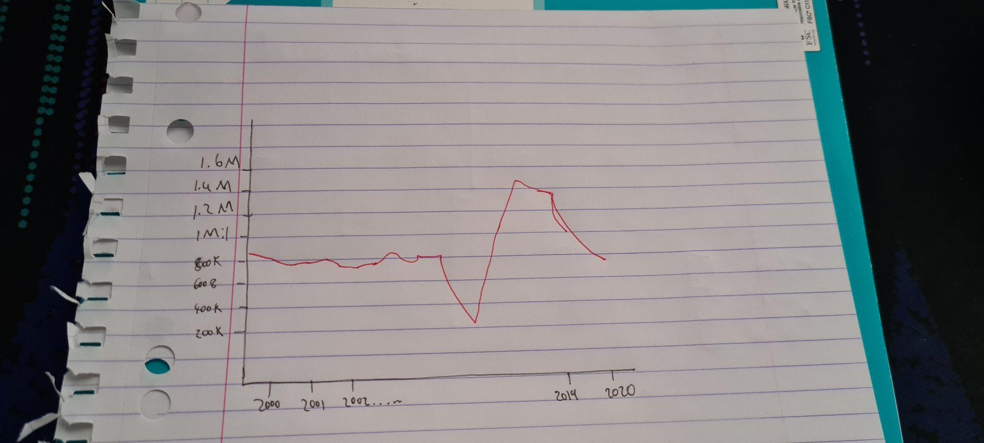

[Process Book.docx](https://docs.google.com/document/d/1CCgAlNuFpm797ozaXVdlrIaYNxuv4r6f/edit)

4th: Heap Map, Percentage of people with a migration background (<https://www.destatis.de/DE/Themen/Gesellschaft-Umwelt/Bevoelkerung/Migration-Integration/_inhalt.html#sprg475904>)

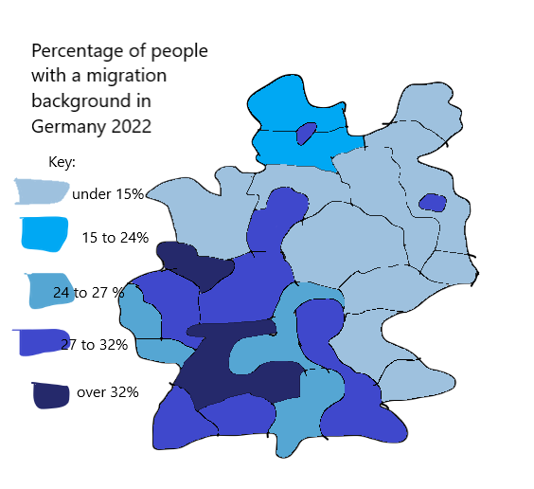

(trying to draw on trackpad and using paint is awful)



5th: Vertical bar chart, Age structure of those seeking protection (<https://www.destatis.de/DE/Themen/Gesellschaft-Umwelt/Bevoelkerung/Migration-Integration/_inhalt.html#sprg475904>)

